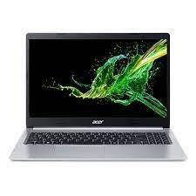

Acer Aspire 3

* Core I7 7th Gen 7700HQ
* 2-GB GDDR5
* 01 TeraByte Hard Drive
* 8 GB DDR4

**Rs.120,000.00**